PHP and MySQL

Session 4 Practical Sessions

This week you will create a simple shopping application that sells widgets. The application will request the number of widgets the client wishes to order and then on a separate page their preferred colour. Finally, a third page will confirm the qty and colour selected.
The Web Application design is below – familiarise yourself with the design before looking at the scripts on the following page.

<<Client Page>>

shop.html

<<Form>>
selqty:select
button1:submit
<<Server Page>>

selectcolour.php
<<submit>>

<<build>>

<<Client Page>>

<<Form>>
selcolour:select
button1:submit
<<Server Page>>

confirmation.php
<<submit >> >>>>submit>>

<<build>>

<<Client Page>>

Create the three files below and run the application by loading shop.html into your browser.
Does the confirmation display both the qty and colour ?

The file below should be saved as shop.html
<html>
<head>
<title>Shopping Page</title>
</head>
<body>
<form action="selectcolour.php" method="post">
Select the qty of widgets you require
<select name="selqty">
<option>1</option>
<option>2</option>
<option>3</option>
<option>4</option>
<option>5</option>
</select>
<br/><br/>
<input type="submit" value="Buy"/>
</form>
</body>
</html>

The file below should be saved as selectcolour.php
<html>
<head><title>Select colour page</title></head>
<body>
<form action="confirmation.php" method="post">
Select the colour for the <?php echo $_POST[selqty] ?> widgets you are ordering
<select name="selcolour">
<option>white</option>
<option>red</option>
<option>yellow</option>
<option>green</option>
<option>blue</option>
</select>
<br/><br/>
<input type="submit" value="Buy"/>
</form>
</body>
</html>

The file below should be saved as confirmation.php
<?php
echo "<h2> Your order qty is $_POST[selqty] </h2></br>";
echo "<h2> and the selected colour is $_POST[selcolour].</h2>"
?>

Exercise 1
Your first task this week is to amend the code so that the qty of widgets is displayed within confirmation.php . Try each of the following methods

- Hidden fields

Changes to the Code:

No changes to the shop.html
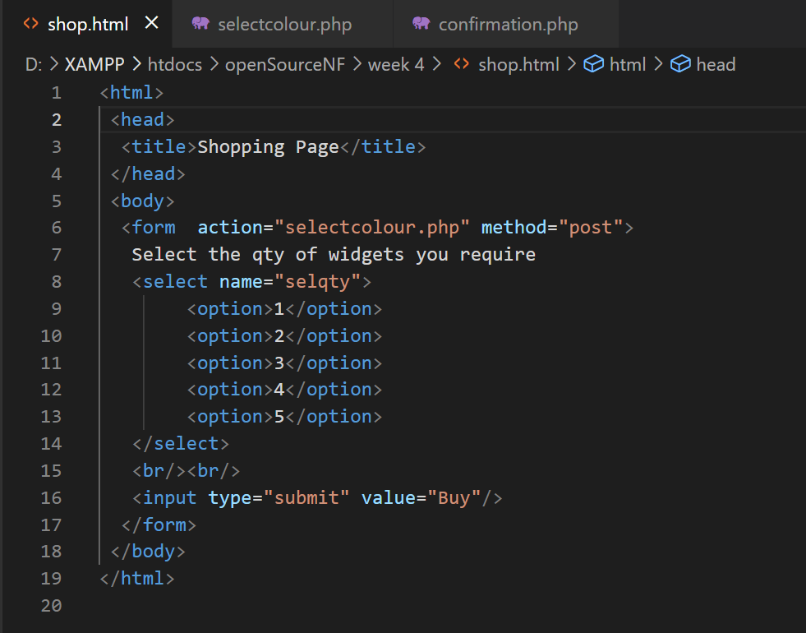

Added the input type hidden
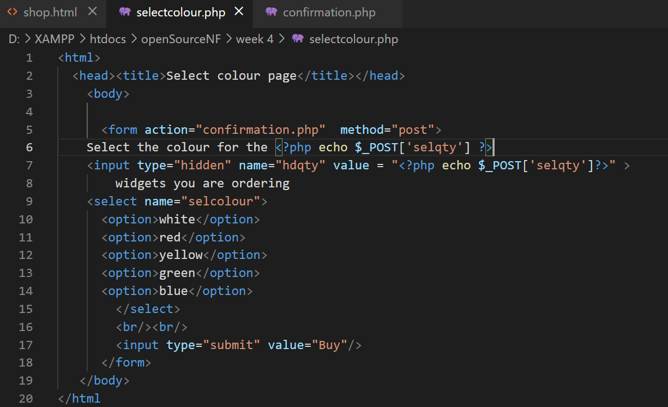

Changes to the Post array to hdqty
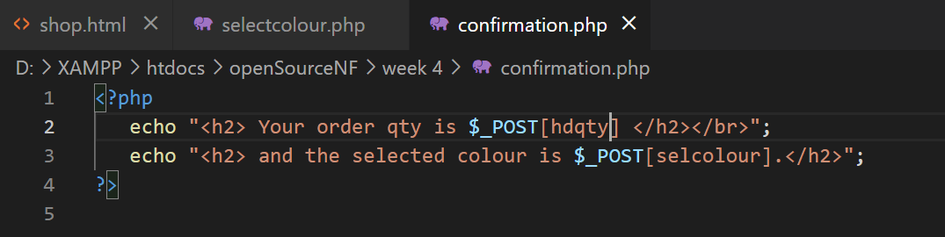

Result to the Code:

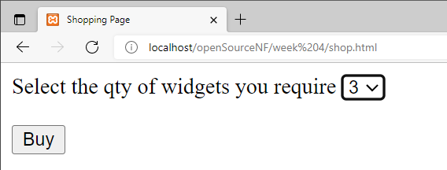

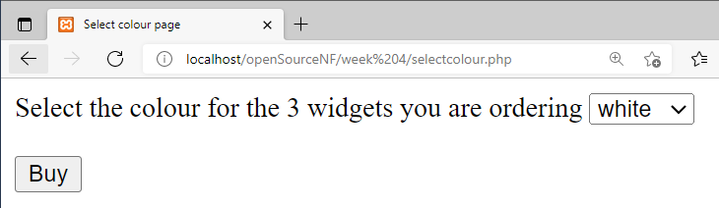

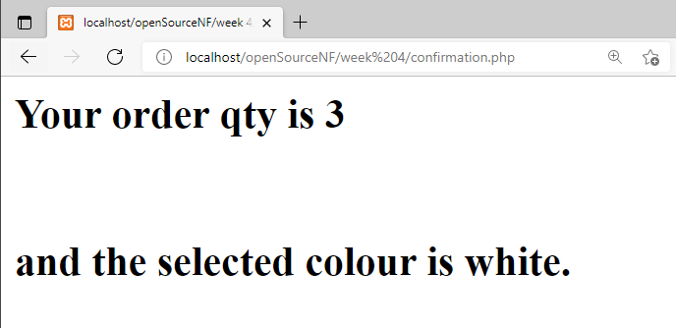
- Cookies

Changes to the Code:

No changes to the shop.html
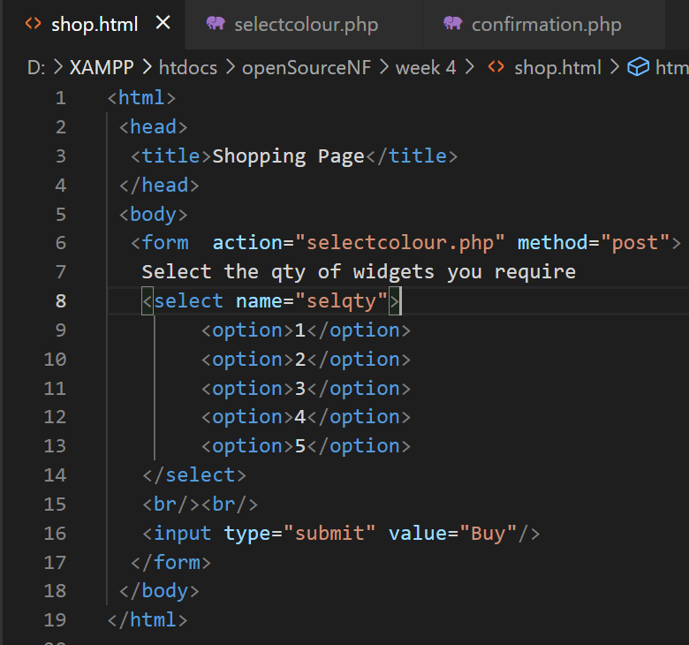

Added added a cookie name variable and setcookie for the selquantity
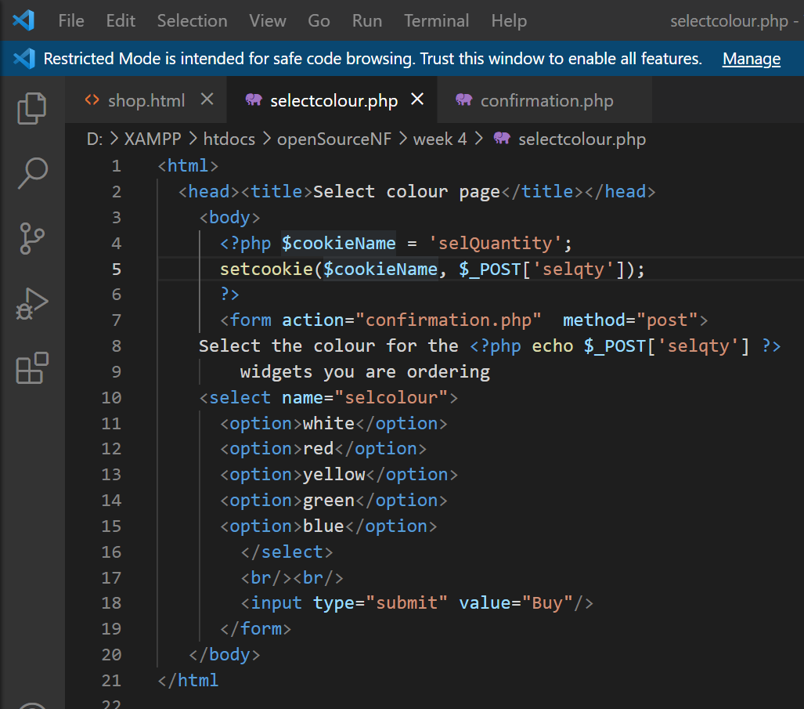

Used the cookie function and used the selquantity array
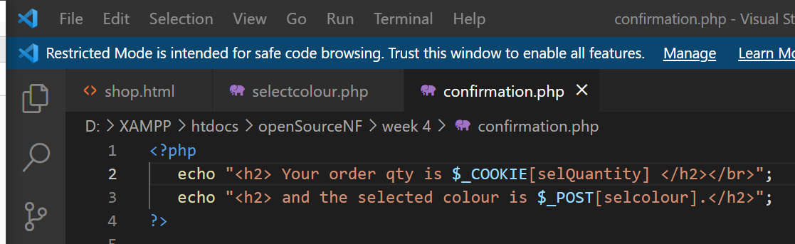

Result to the Code:

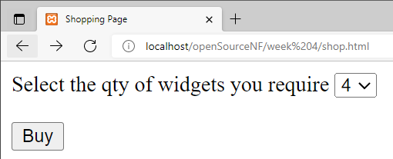

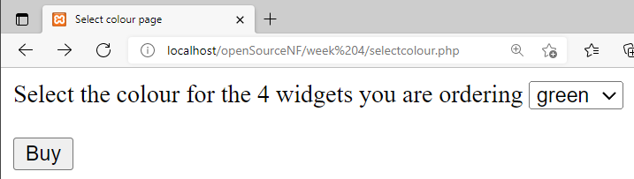
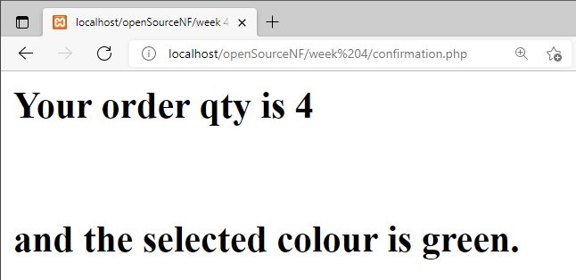

- Session variables

Changes to the Code:

No changes with the shop.html
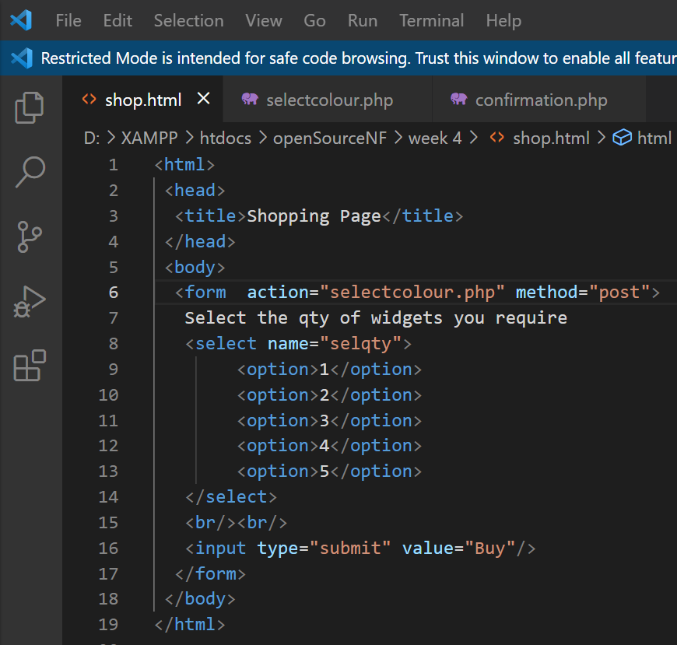

Added a sesseion varaiable
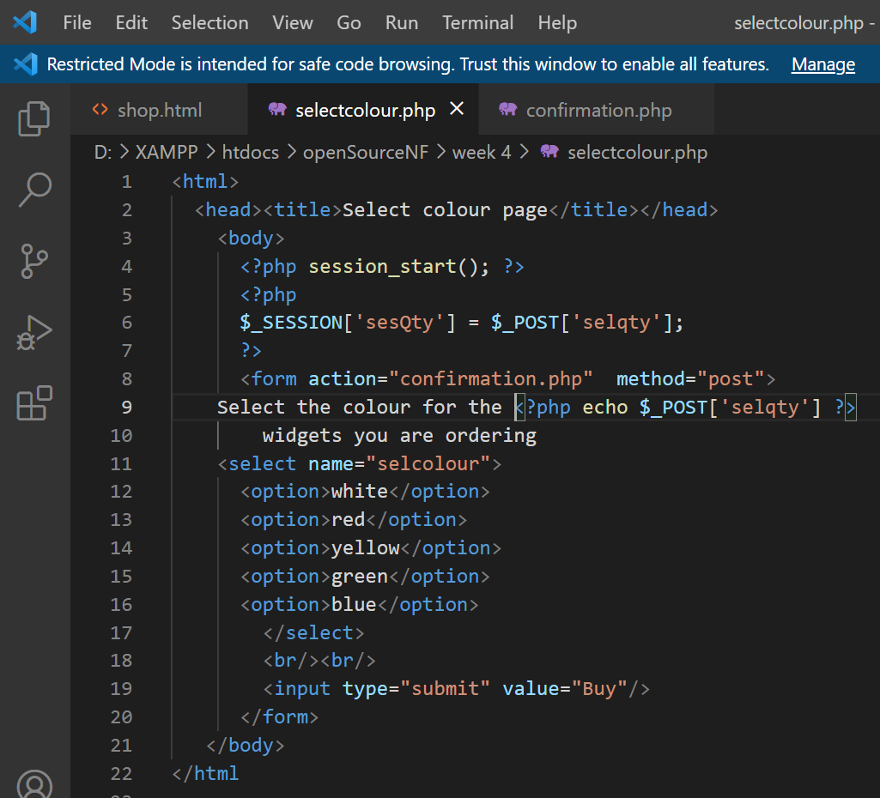

Added session start nad used the sesQty array for the session
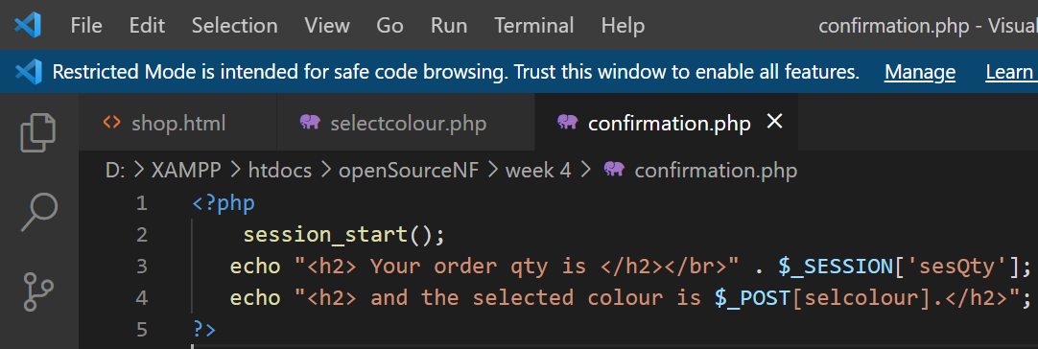

Result to the Code:

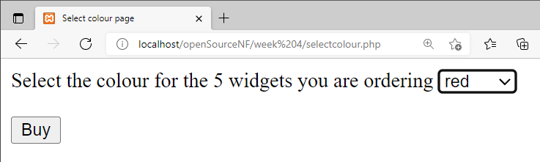

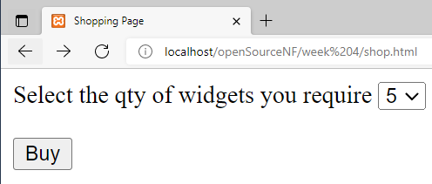

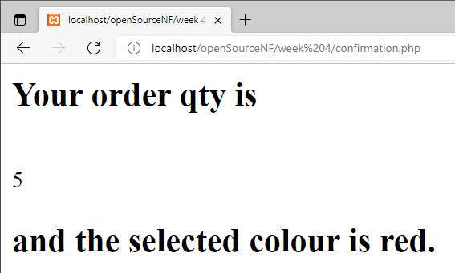

Use the example applications on the back of this practical as a guide.
Which of the three methods was easiest to implement ?

The hidden is the easiest to implement

Exercise 2
You may have noticed that no prices have been included within the application. Our customer was not happy about this, stating that “I’m not a running a charity !“ or words to that effect.

Your next task is to include a price for the widgets and for a total price ( qty * price ) to be displayed within confirmation.php. The initial price should be displayed within shop.html. One solution would be to include the following line

<input type=”text” name=”txtprice” size=”10” value=”15.75” readonly />

after the select control that displays the qty.

Use any of the three methods to access the price within confirmation.php so that a total cost can be calculated and displayed.

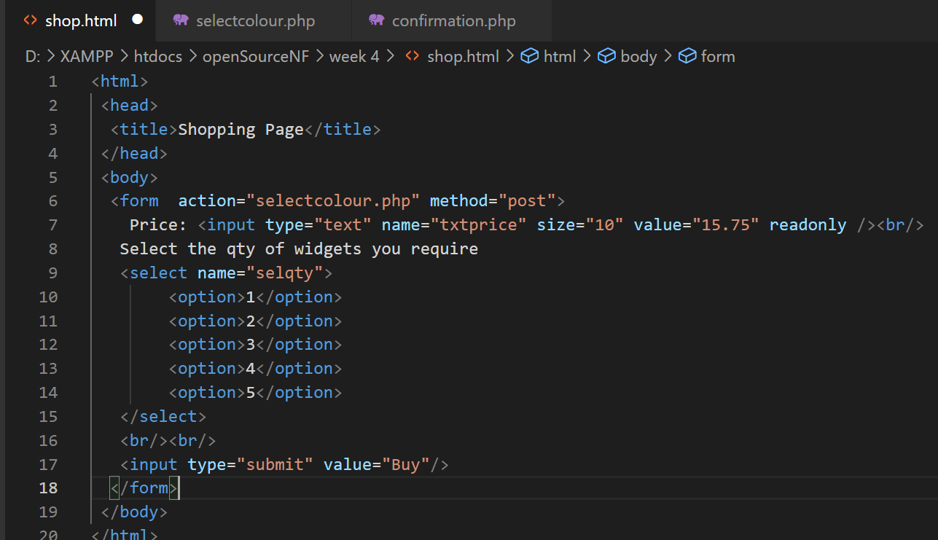
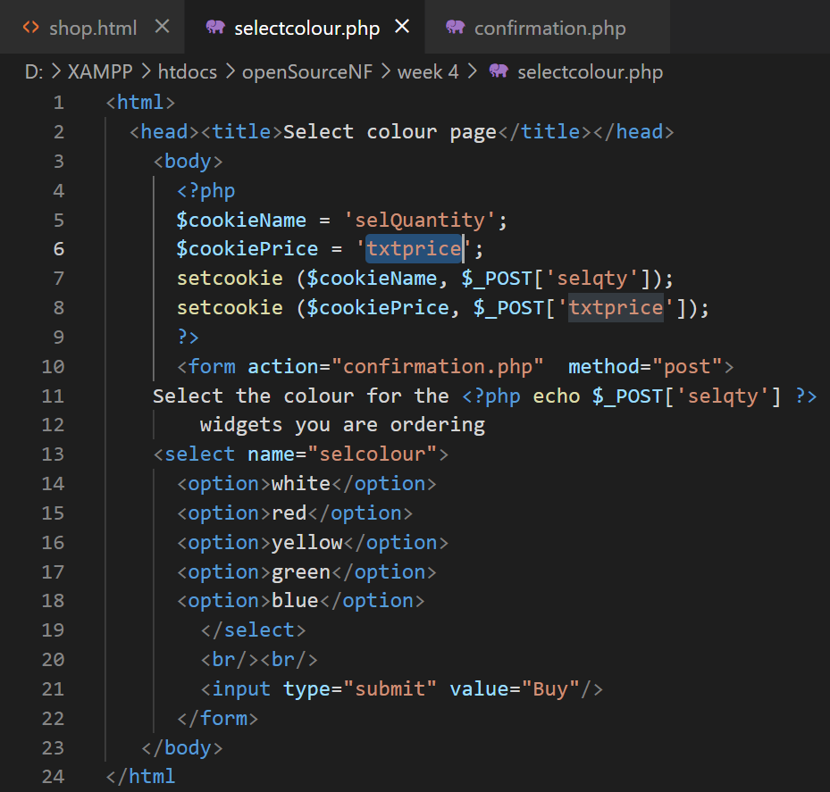

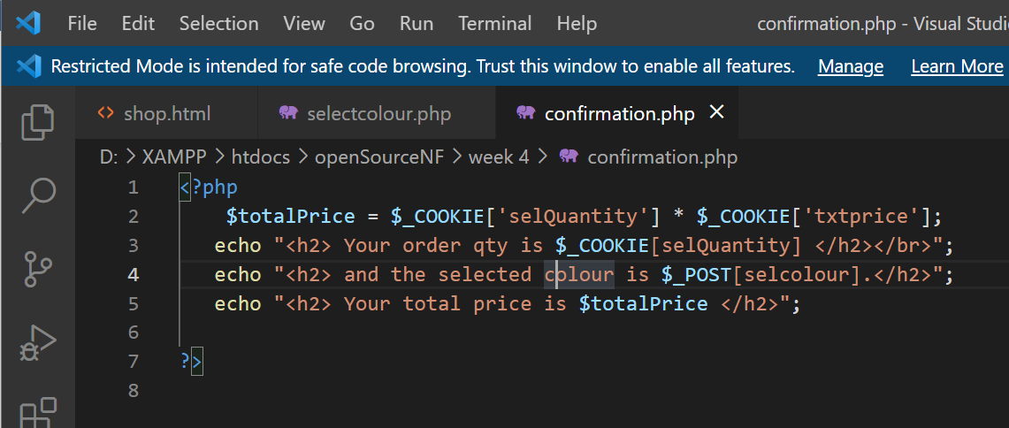

Result:

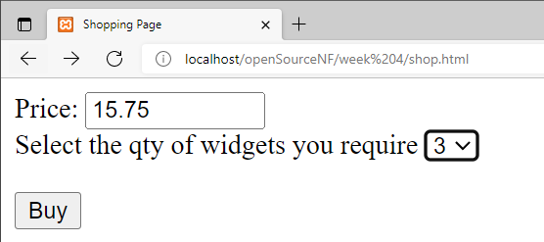

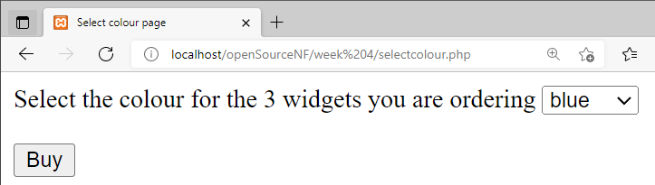

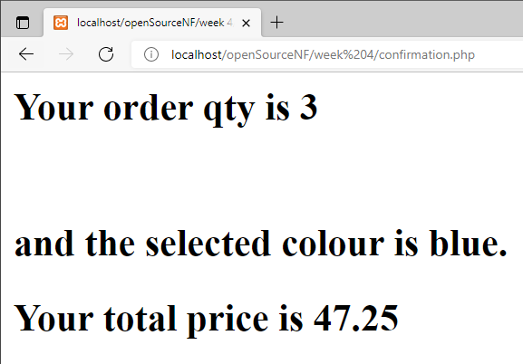

Exercise 3
Our customer has decided to sell different sizes of widgets. They now come in the following sizes.
- Small (£15.75)
- Medium (£16.75)
- Large (£17.75)
- Extra large (£18.75)

Create a new page called size.php for size selection, it should be displayed after the qty is selected but before the colour. Remember to change the form’s action attributes within shop.html to ensure the pages are called in the correct order. The price now depends upon the size selected, so you will need to remove the txtprice tag from shop.html. Make the amendments necessary to ensure the correct calculation of the final cost within confirmation.php ( hint : within confirmation.php you could use a switch statement to determine which size was selected and then calculate the overall cost accordingly.

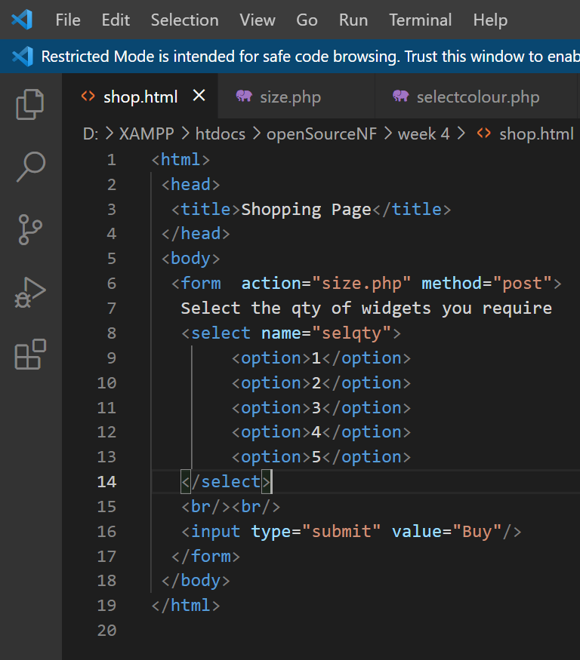

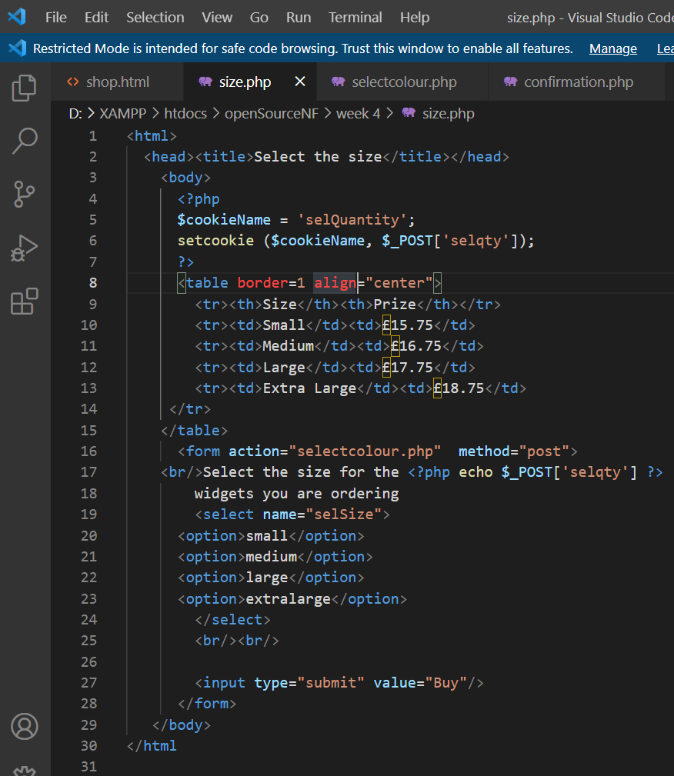

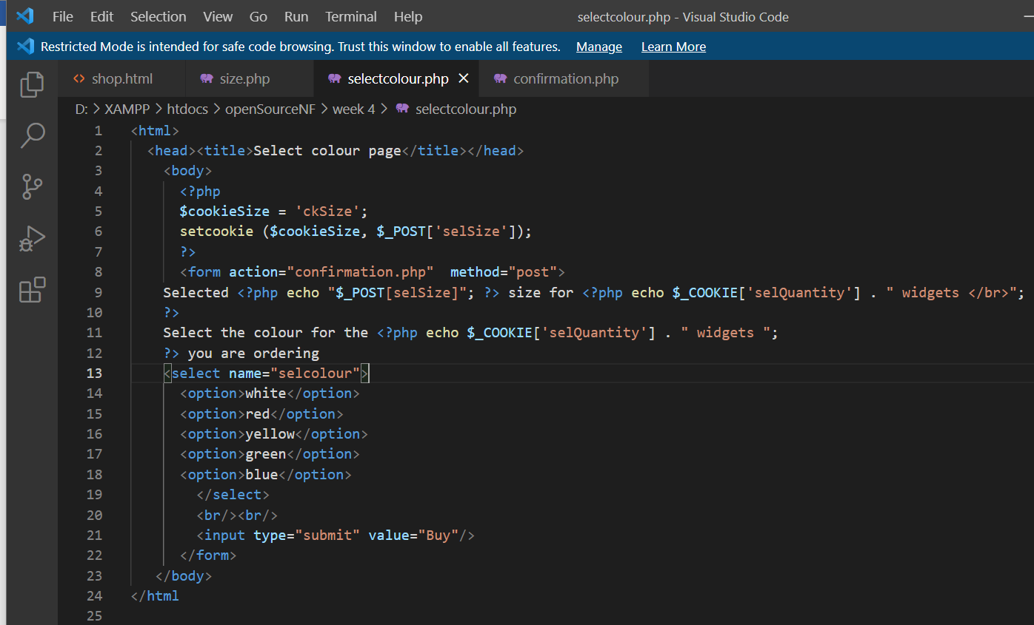

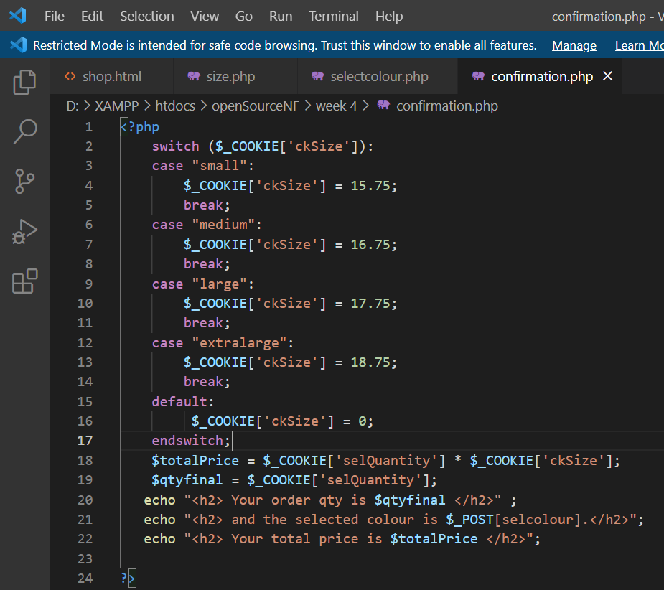

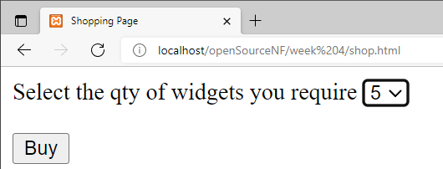

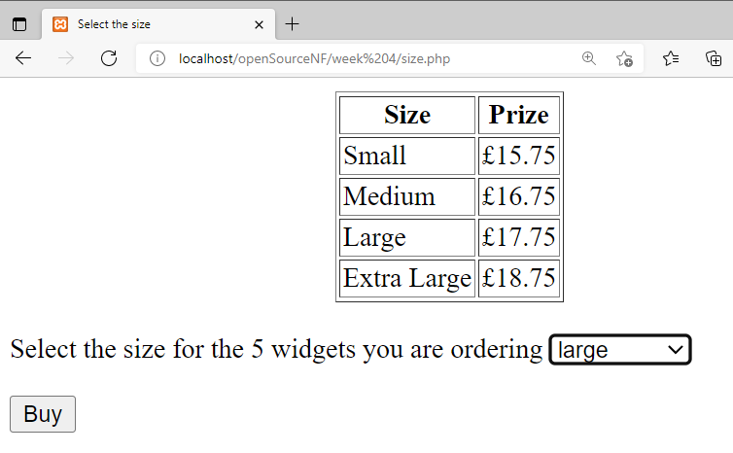

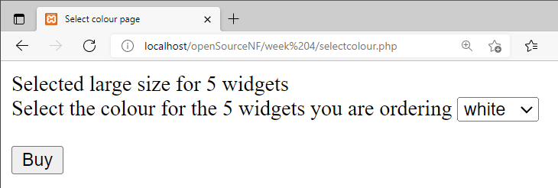

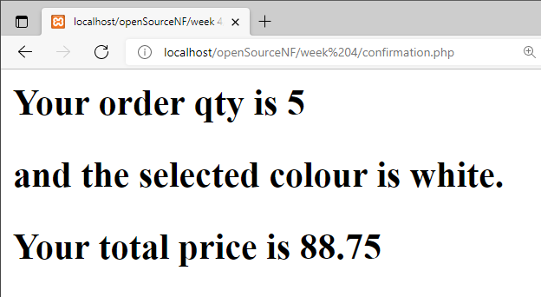

Exercise 4
Draw a design for the revised shop. Ensure you include all the detail – Client & Server Pages, Forms and any controls that are contained within them.

Exercise 5

Complete the third unit on the SoloLearn PHP course either via the web or via the mobile: https://www.sololearn.com/Play/PHP

In your final logbook/handout, you will be asked to provide evidence that you completed the whole course in the form of a screenshot of your progress or a screenshot of the certificate of completion.

Notes:

Example applications for implementing “Hidden fields”, “Cookies” and “Session variables” (from Lecture)

